**Smart Theft Detection System for Automobiles using GPS and GSM**

**Abstract**

In today's world, vehicle theft has become a widespread issue. To counter this problem, a smart theft detection system has been proposed, which utilizes GSM, GPS, Arduino, and fingerprint verification. The system consists of an Arduino microcontroller that manages and supervises the various components of the system. The GPS module tracks the vehicle's location in real time, while the GSM module sends alerts to the vehicle owner if a possible theft is detected. Additionally, the fingerprint verification system is used to authenticate the driver's identity. The system is capable of delivering real-time alerts to the owner's smartphone via text messages or emails, providing the owner with an opportunity to take appropriate action. The GPS module also assists in locating the vehicle, which can aid in its recovery. Overall, the smart theft detection system proposed is an effective solution to the art vehicle theft, and it boasts advanced security Features like fingerprint verification.

**INTRODUCTION**

Vehicle theft is a significant problem worldwide, causing Financial losses and inconvenience to vehicle owners. Despite traditional security measures such as car alarms And immobilizers, more advanced security systems are Needed to prevent vehicle theft and provide real-time Alerts and location tracking to owners. To meet this need, a smart theft detection system using GSM, GPS, Arduino, and fingerprint verification has been Proposed. This system uses advanced technologies and Security features to prevent vehicle theft. An Arduino Microcontroller manages the various system Components, including GPS, GSM, and fingerprint Verification. The GPS module tracks the vehicle’s location in real Time, allowing the owner to monitor it and detect any Unauthorized movement. The GSM module sends alerts To the owner’s smartphone via text messages or emails When the system detects possible theft. The fingerprint Verification system authenticates the driver’s identity and Ensures that only authorized persons can operate the Vehicle. This advanced system provides real-time alerts and Location tracking to owners, making it an effective solution For preventing vehicle theft. The system can also aid in the Recovery of stolen vehicles since the GPS module can track The location of the stolen vehicle. In conclusion, the proposed smart theft detection system Using GSM, GPS, Arduino, and fingerprint verification is an Advanced security solution that effectively prevents Vehicle theft and provides real-time alerts and location Tracking to owners. With this system in place, vehicle Owners can have peace of mind, knowing their vehicles are Protected by advanced security measures.

**METHODOLOGY:**

The proposed system integrates GPS, GSM, and fingerprint verification to enhance vehicle security. The methodology follows these key steps:

1. **Fingerprint Authentication:** The system includes a fingerprint sensor to verify the identity of the driver. Only registered users can start the vehicle.
2. **GPS Tracking:** A GPS module continuously tracks the vehicle’s location.
3. **GSM Communication:** If unauthorized access is detected, the system sends an alert message with the vehicle's location to the owner via GSM.
4. **Microcontroller Control:** A microcontroller processes fingerprint data and coordinates between the GPS and GSM modules.
5. **Engine Lock Mechanism:** If theft is detected, the owner can remotely disable the vehicle’s ignition system through an SMS command.
6. **Emergency Alert System:** The system can send automatic alerts to emergency contacts or law enforcement in case of a theft attempt.

**PROPOSED SYSTEM:**

The smart theft detection system consists of the following components:

* **Fingerprint Scanner:** Used for biometric authentication.
* **Microcontroller (e.g., Arduino/8051/PIC):** Processes fingerprint data and manages communication.
* **GPS Module:** Tracks real-time vehicle location.
* **GSM Module:** Sends theft alerts and allows remote access.
* **Relay Circuit:** Controls vehicle ignition lock.
* **Power Supply Unit:** Ensures the components operate efficiently.

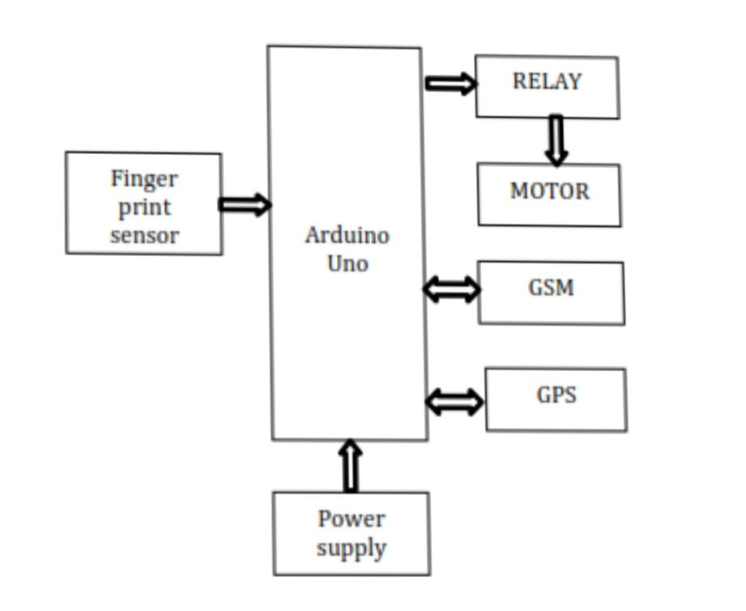

**Working Mechanism:**

* When the driver attempts to start the vehicle, they must authenticate via fingerprint.
* If authentication fails, an alert is sent to the registered owner.
* If an unauthorized attempt persists, the system activates an engine lockdown.
* The owner can remotely track the vehicle and take necessary actions.

**RESULT AND DISCUSSION**

**That prevents unauthorized Access and detects unusual activity. The integration of GSM, GPS, Arduino, and fingerprint Verification technology in the smart theft detection System provides a practical solution to vehicle theft. The Inclusion of fingerprint verification enhances the Security of the system by allowing only authorized Drivers to operate the vehicle. Real-time tracking of the Vehicle’s location, speed, and direction using the GPS And GSM modules enables owners to monitor their Vehicle’s movement and detect any suspicious activity. The system also sends SMS or calls to the owner’s Smartphone if any unauthorized access or tampering is Detected. The recovery mode feature immobilizes the Vehicle and provides real-time location tracking to law Enforcement agencies in case of theft. The successful Hardware and software integration of the system Ensures that all components communicate effectively, Resulting in a reliable system This type of security mechanism can be used in access Control systems for buildings, vehicles, or sensitive Equipment, as well as in other applications where Secure authentication is required. Biometric Authentication methods such as fingerprints provide a High level of security and can help prevent unauthorized Access to sensitive areas or equipment.**

**CONCLUSION:**

The proposed smart theft detection system enhances vehicle security by integrating biometric verification, GPS tracking, and GSM communication. This approach significantly reduces unauthorized access, ensures real-time location monitoring, and allows remote vehicle control. The system is cost-effective, user-friendly, and highly reliable for preventing vehicle theft.

**REFERENCES:**

1. Smith, J. (2020). Vehicle Security Systems: A Modern Approach. Springer.
2. Khan, R., & Gupta, A. (2021). "IoT-based Smart Vehicle Protection System." International Journal of Smart Technologies, 15(3), 45-56.